# Workshop: Cubicle - Part 2

"*Cubicle*" is a place, where you can browse some of the most popular rubik cubes in the world and add some new cubes that you have discovered.

This application was created as a workshop for the [JS Back-End course](https://softuni.bg/trainings/2452/js-back-end-september-2019) at the [Software University](https://softuni.bg).

If you missed the first part of this workshop, you can download the [Document](http://svn.softuni.org/admin/svn/js-web/Sept-2019/JS-Back-End/03.%20JS-Back-End-ExpressJS-and-Templating/03.%20Cubicle-Workshop-Part-1.docx) and the [Resources](http://svn.softuni.org/admin/svn/js-web/Sept-2019/JS-Back-End/03.%20JS-Back-End-ExpressJS-and-Templating/03.%20Cubicle-Workshop-Part-1-Resources.zip) and complete it before you start this one (use **username: student** and **password: student** to do that).

## Main task

If you able to complete the previous task, good job! Now it's time to **upgrade** your app and **implement** a few new features. For instance, to replace the way you **store** data using **MongoDB** and **Mongoose**, **creating** and **attaching** **new** **accessories** to each **cube**, make some **relations** between them and **include** a few more **pages**.

## Installing dependencies

As you already know, you should **install** a bunch new things so you could be able to continue with this part of the workshop.

Here's the list:

1. [MongoDB Download Center](https://www.mongodb.com/download-center) - You can check the [Installation Instructions](https://docs.mongodb.com/manual/tutorial/install-mongodb-on-windows/) as well
2. [MongoDB Node.JS Driver](https://www.npmjs.com/package/mongodb)
3. [Mongoose](https://www.npmjs.com/package/mongoose) - **Very useful** [**Mongoose Documentation**](https://mongoosejs.com/docs/guide.html)
4. [Robo 3T](https://robomongo.org/download)

## Database Connection with ExpressJS

Your **database**.**json** file inside **config** **folder** will be **modified**, because you **no longer** will **store** the data in **json** file. So, make sure inside it, the **mongoose** **connection** via **MongoDB connection string** is **made** and **exported.**

The **index.js** file should **require** the exported mongoose connection (**database**) before the server starts.

## Model

If you follow the previous structure you probably created ES6 class Model for each cube in this format:

* **Id** - number
* **Name** - string
* **Description** - string
* **Image URL** - string
* **Difficulty** **Level** - number

Now it's time to refactor this ES6 class to **Mongoose** **Schema**, so each **Cube** has the following structure:

* Id - (**ObjectId)**
* Name - (**String**, **required**)
* Description - (**String**, **required,** **max length validation**)
* ImageUrl - (**String**, **required**, **http/https validation**)
* Difficulty Level - (**Number**, **required**, **min and max valid range**)
* Accessories - (**ObjectId**, **ref** **Accessories** **Model**)

And create another model (**Accessory**) in the following format:

* Id - (**ObjectId**)
* Name - (**String**, **required**)
* ImageUrl - (**String**, **required**, **http/https validation**)
* Description - (**String**, **required**, **max length validation**)
* Cubes - (**ObjectId**, **ref** **Cubes** **Model**)

Your models folder should look like:

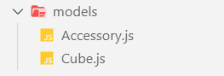

## Database Persistence

**All** **pages** in the application should persist data to **MongoDB** & work with **MongoDB**

## Additional Pages

You should implement **2** new routes:

* **/create/accessory** - should render the create accessory form
* **/attach/accessory/:id** - should render the accessory page about attaching new accessory for cube

And **update the view** on **/details/:id** route, that render the cube's details

Use the provided [**Resources**](http://svn.softuni.org/admin/svn/js-web/Sept-2019/JS-Back-End/04.%20JS-Back-End-NoSQL-and-MongoDB/04.%20Cubicle-Workshop-Part-2-Resources.zip) to create the additional templates using Handlebars (The authentication here is the same as above - **username: student**, **password: student**). Identify the dynamic parts and use appropriate syntax for interpolating and rendering the application context. Replace the old **CSS** file with the given one.

### Create accessory page view

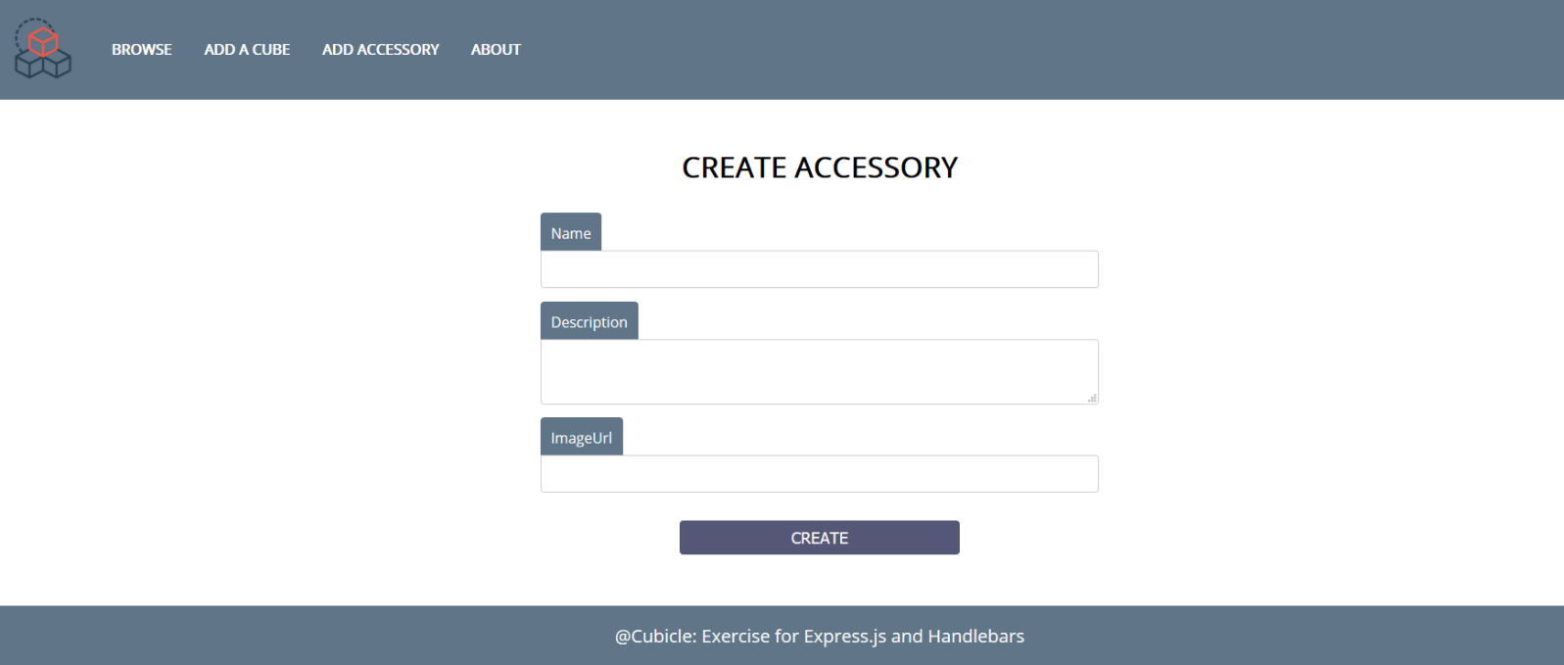

Attach new accessory view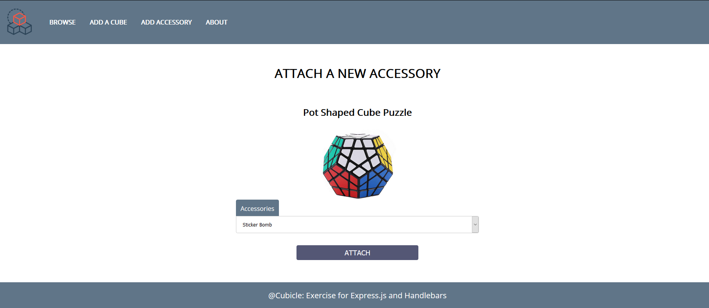

***Note that, the options inside the select element must be only these ones which the current cube doesn’t have attached to itself.***

### Updated details page view

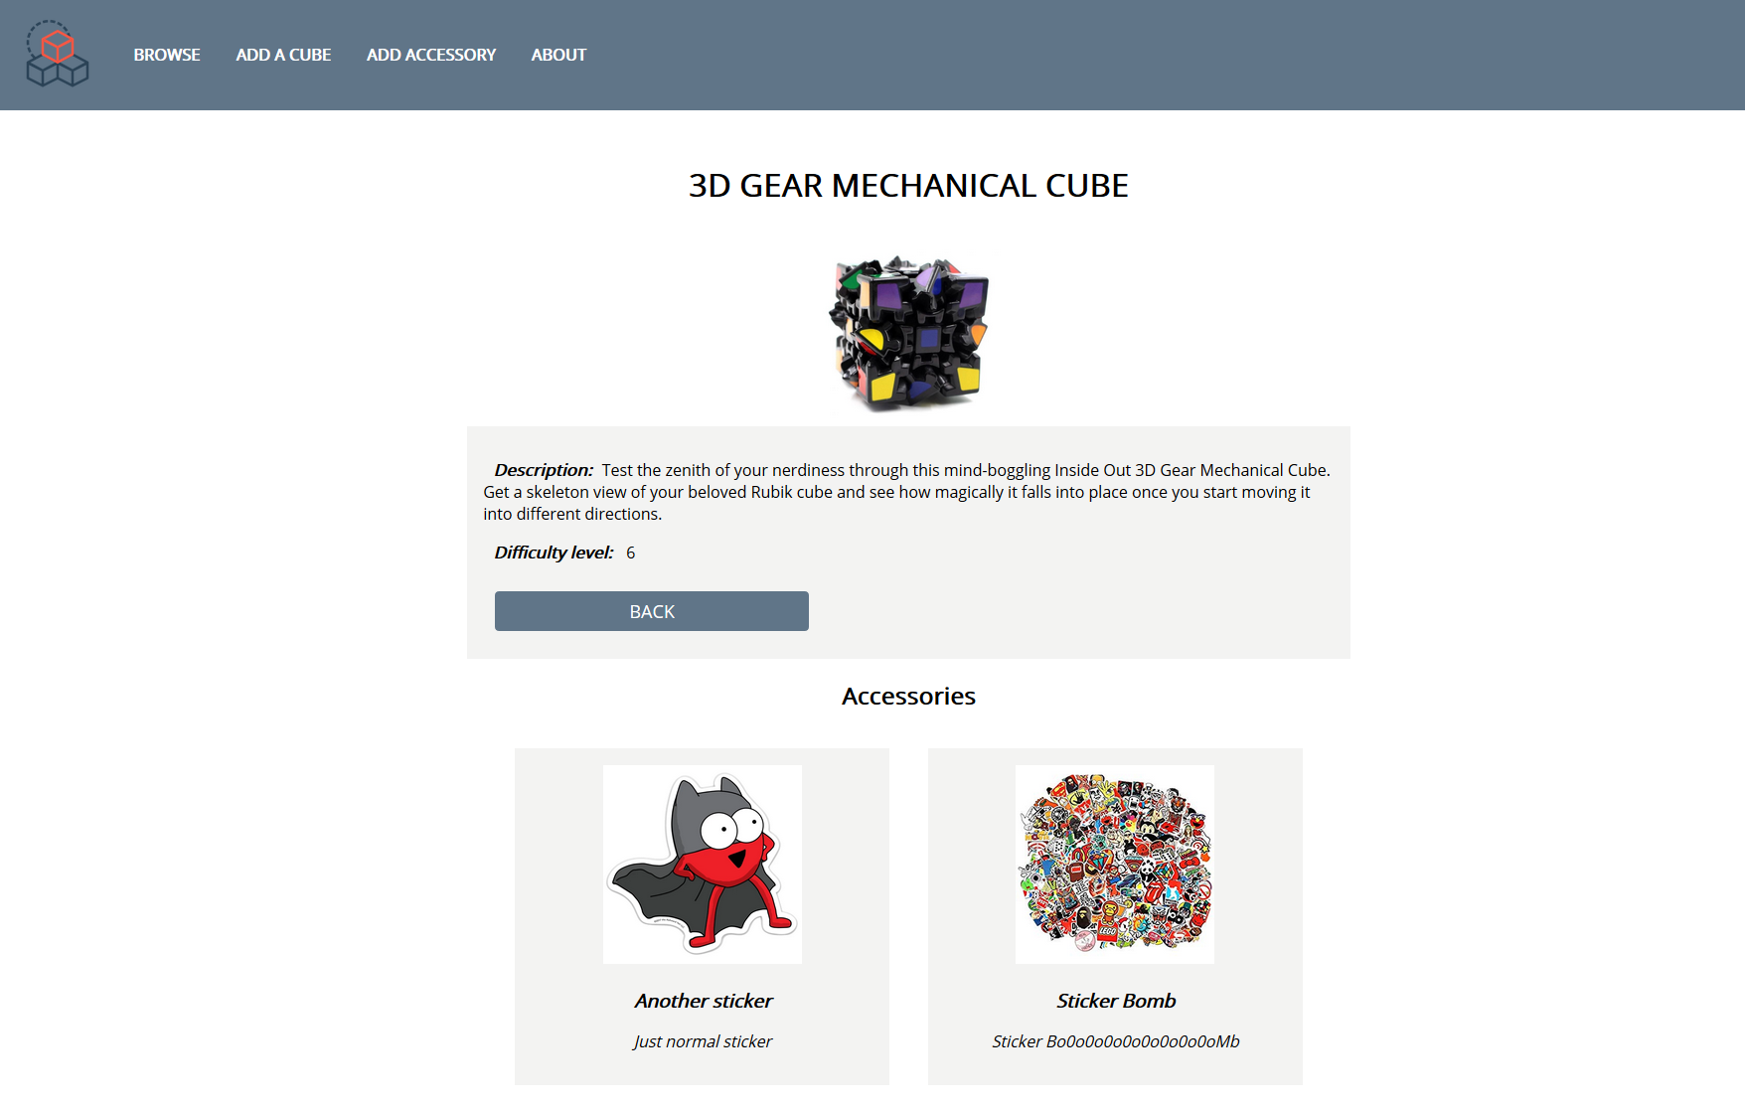 **Good Luck! 😊**